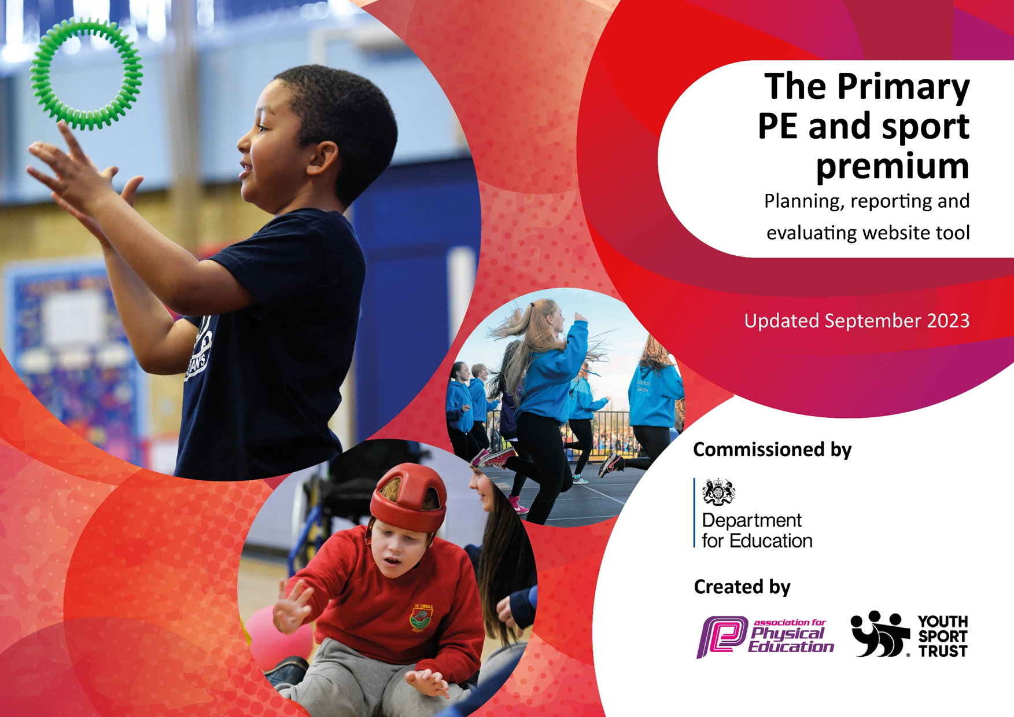
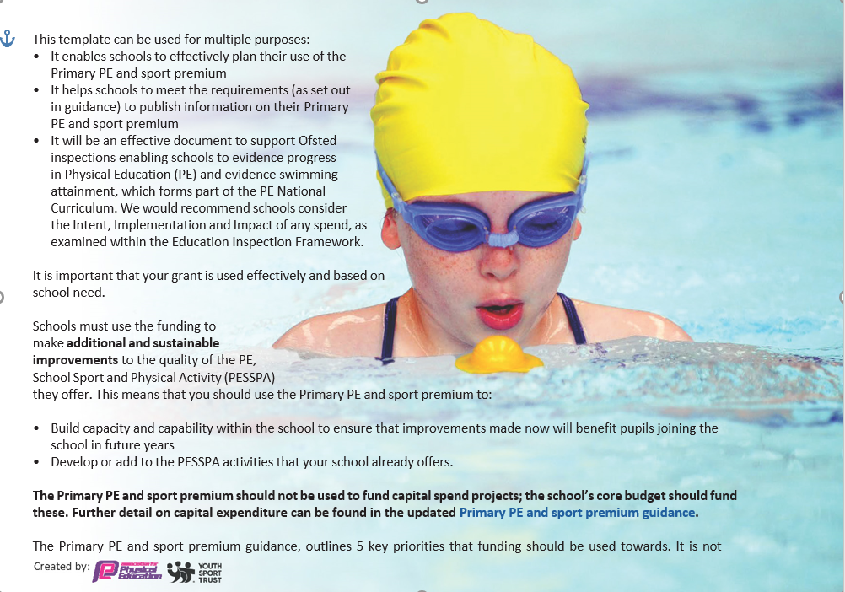
necessary that spending has to meet all the key priorities, you should select the priorities that you aim to use any funding towards.

Although completing this template is not a requirement for schools, schools are required to publish details of how they spend this funding. Schools must also outline what the impact this funding has had on pupils’ PE and sport participation and attainment and how any spending will be sustainable in the future. All funding must be spent by 31st July 2024.

The Department for Education has worked closely with the Association for Physical Education (afPE) and the Youth Sport Trust (YST) to develop this template and encourages schools to use it. This template is an effective way of meeting the reporting requirements of the Primary PE and sport premium.

Action Plan and Budget Tracking
Capture your intended annual spend against the 5 key indicators. Clarify the success criteria and evidence of impact that you intend to measure to evaluate for pupils today and for the future.

Academic Year: 2023/24 | Total fund allocated: £18,870 | Date Updated: 1.7.2024
Key indicator 1: The engagement of all pupils in regular physical activity – Chief Medical Officers guidelines recommend that primary school pupils undertake at least 30 minutes of physical activity a day in school
Intent | Implementation |  | Impact
 |  | Funding: |  | Sustainability and suggested next steps:
To provide opportunities so pupils can enjoy physical activity and build strong foundations to lead a healthy lifestyle through their lives | Ben Pearce Coaching delivering an after school Multi-Sports Club focusing on providing disadvantaged pupils with the experience of a variety of sports/activities with a competitive edge.  PE Subject Leader to liaise with Sports Coaches and Staff to deliver an increased range of sports and activities so different skill sets can be incorporated to encourage a lifetime participation in sport and physical activity.  PE Subject Leader to liaise with external sports coach and teaching staff and purchase necessary equipment.  PE Subject Leader to ensure outdoor/playtime equipment is up to date and provides pupils with opportunities to develop their skills  PE Subject Leader to train 6 Sports Leaders who will organise games every lunchtime on the main playground.  Year 2 children to attend a gymnastics competition: | BP Cost = £12,240  The remaining £6,330 has been spent on staff training, equipment and resources, facilities and infrastructure, competitions and Healthy School Week (healthy and wellbeing initiatives). | We have provided disadvantaged pupils with access to a variety of sports and activities, promoted inclusivity and diversity in physical education. The competitive edge has fostered a sense of teamwork, sportsmanship, and healthy competition among the children  We have incorporated different skill sets and a diverse range of sports. We have encouraged children to explore and discover their interests and strengths, promoting a well-rounded approach to physical activity. We have enhanced engagement in physical education, improved coordination and agility.  Children have had access to expert coaching and appropriate equipment has enhanced the quality of physical education delivery, ensuring children receive proper guidance and resources to develop their skills.  Up-to-date equipment has provided children with safe and engaging opportunities to develop their physical skills, creativity, and social interactions during playtime.  This has been moved to the start of Autumn 2024 so it can be rolled out all year.  Participation in a gymnastics competition has provided children with a goal-oriented and challenging experience, promoting skill development, resilience, and teamwork.  It has enhanced their gymnastics skills, exposure to competitive sports environments, increased confidence, and a sense of achievement and pride in representing their school. | To motivate and encourage parents/carers to attend Multi-Sports with their children. To continue an achievement assembly and weekly medal to celebrate the children’s sporting achievements. To increase the group size so more children can benefit from the multi-sports club  Continue to use equipment to allow pupils to try a range of different sports and activities. Discuss and review which sports and activities children enjoyed/would like to try next year. Provide opportunities to teach a wide range of different activities and sports  Continue to use equipment to allow pupils to try a range of different sports and activities.  To continue next year.
Key indicator 2: The profile of PESSPA being raised across the school as a tool for whole school improvement
Intent | Implementation |  | Impact
 |  | Funding: |  | Sustainability and suggested next steps:
To develop a positive school approach to physical activity and physical education which encourages staff, parents/carers and pupils to build a habit of lifetime participation. | Increase opportunities so pupils can improve their physical activity participation throughout the school day and to link the importance of physical activity with leading a healthy lifestyle.  Allow class teaching time so pupils can form positive links between physical education and wellbeing.  Provide facilities to an external Football, Rugby and Multi-sport club.  Ben Pearce Coaching delivering an after school Multi-Sports Club focusing on providing disadvantaged pupils with the experience of a variety of sports/activities with a competitive edge.  Provide competitive sporting opportunities, including an inclusion sporting event that gives competitive opportunities to pupils whom wouldn’t get the opportunities out of school.  Ben Pearce to upskill MLD unit staff in the delivery of PE  Star Travel scheme to take place every other half term to motivate pupils and adults to walk, cycle or use a scooter to travel to school.  PE Subject Leader to train 6 Sports Leaders who will organise games every lunchtime on the main playground.  Promote the importance of leading an active and healthy lifestyle through a variety of activities during Healthy School Week | BP Cost = £12,240  The remaining £6,330 has been spent on staff training, equipment and resources, facilities and infrastructure, competitions and Healthy School Week (healthy and wellbeing initiatives) | Promoted a culture of physical activity and wellbeing, instilled healthy habits and encouraged children to be active throughout the day.  The integration of physical education into the curriculum has reinforced the importance of physical activity and mental wellbeing, fostering holistic development in children.  We have enhanced extracurricular opportunities for children to engage in sports, promoting teamwork, skill development, and a love for physical activity. We have also increased participation in sports clubs, improved sports skills, enhanced social interactions, and a sense of belonging and achievement for the children.  We have provided underprivileged children with access to a variety of sports and activities, promoting inclusivity, skill development, and competitive experiences.  We have increased participation, improved physical fitness, enhanced sports skills, boosted confidence, and a sense of accomplishment for disadvantaged pupils.  We have fostered a sense of sportsmanship, teamwork, and fair play, while providing all children with opportunities to participate in competitive activities.  We have enhanced the capacity of staff to support children with additional needs in physical education, promoting inclusivity and tailored support for diverse learners. We have improved delivery of PE for children with special educational needs, increased engagement and participation, and a more inclusive and supportive learning environment.  We have promoted active travel habits among children and adults, encouraging sustainable and healthy modes of transportation to school  This has been moved to the start of Autumn 2024 so it can be rolled out all year.  We have raised awareness about the importance of leading an active lifestyle and making healthy choices, promoting physical, mental, and emotional well-being. | To train Sport Leaders next year. Train Year 1 and Year 2 Sport Leaders to engage more children in active playtimes.  To continue to teach the links between physical education, physical activity and wellbeing. Class Teachers to use the whiteboard when teaching PE to address and discuss the positive links. Teachers to increase their use of Knowledge Organisers during PE.  Continue and increase to provide our facilities to allow and external football club to take place.  To motivate and encourage parents/carers to attend Multi-Sports with their children. To continue an achievement assembly and weekly medal to celebrate the children’s sporting achievements. To increase the group size more children can benefit from the multi-sports club.  To continue to compete in Hinckley and Bosworth Gymnastics competition. To work closely with H&BSSN to increase local competition opportunities.  All MLD staff to be confident in delivering fun, competitive and active lunchtime sessions which engage a range of pupils. MLD leaders to be confident in delivering PE sessions using GetSet4PE.  To continue to provide a scheme as an incentive to walk, cycle of use a scooter to travel to school.  Continue to promote a healthy lifestyle throughout the school day (PE sessions, lunchtime food choices, PSHE).

Key indicator 3: Increased confidence, knowledge and skills of all staff in teaching PE and sport
Intent | Implementation |  | Impact
 |  | Funding: |  | Sustainability and suggested next steps:
To ensure all pupils have access to high quality PE teaching. | Purchase GETSET4PE scheme to ensure consistency and coverage of a high quality PE teaching  Ben Pearce to deliver high quality P.E sessions for Year 1, Year 2, EYFS and MLD pupils and provide teaching staff with CPD opportunities  Hold community sporting event that promotes healthy living and an active lifestyle.  Staff are to demonstrate activities correctly and discuss the outcomes of each activity/lesson with correct questioning and vocabulary to increase the pupils’ knowledge and understanding.  Subject leader to observe sports coaches on a half termly basis to ensure the quality of sessions being delivered. | BP Cost = £12,240  The remaining £6,330 has been spent on staff training, equipment and resources, facilities and infrastructure, competitions and Healthy School Week (healthy and wellbeing initiatives) | We have ensured consistency and comprehensive coverage of high-quality PE teaching across all year groups, providing structured lesson plans, resources, and support for teachers. We have improved delivery of PE lessons, enhanced learning experiences for children, increased teacher confidence in teaching PE, and a standardised approach to physical education that promotes skill development and engagement.  We have provided children with expert-led PE sessions, tailored to different age groups and learning needs, and offered teaching staff professional development opportunities to enhance their skills and knowledge in delivering PE.  We have encouraged community involvement in physical activity and aimed to increased community engagement.  Staff are now modeling correct techniques and provide clear explanations to children, promoting proper execution of activities, skill development, and understanding of the benefits of physical education.  There have been regular observations of sports coaches to ensure the delivery of high-quality PE sessions, adherence to best practices, and alignment with school objectives and standards. | Continue to enroll in the GetSet4PE scheme for all of our PE Lessons.  Continue to use BP to upskill staff and continue to monitor the provision of the sports coaches. BP to be used across all year groups.  To continue the development of Sports day. To increase activities and continue to invite parents/carers to increase positive competitive experiences. Continue to allow opportunities for staff to run events.  Continue to enroll in the GetSet4PE scheme for all of our PE Lessons. To increase the use of Knowledge Organisers.  Subject Leader to observe EYFS and KS1 teachers to ensure quality teaching.
Key indicator 4: Broader experience of a range of sports and activities offered to all pupils
Intent | Implementation |  | Impact
 |  | Funding: |  | Sustainability and suggested next steps:
To provide opportunities so pupils can have positive experiences of different sports and games. | Ensure 4 after school clubs are ran throughout the year – Multi-sports x2, football and gymnastics  Ben Pearce to deliver high quality P.E sessions for Year 1, Year 2, EYFS and MLD pupils and provide teaching staff with CPD opportunities.  PE Subject Leader to liaise with Sports Coaches and Staff to deliver an increased range of sports and activities so different skill sets can be incorporated to encourage a lifetime participation in sport and physical activity  PE Subject Leader to liaise with external sports coach and teaching staff and purchase necessary equipment.  PE Subject Leader to ensure outdoor/playtime equipment is up to date and provides pupils with opportunities to develop their skills  Run an afterschool Gymnastics Club | BP Cost = £12,240  The remaining £6,330 has been spent on staff training, equipment and resources, facilities and infrastructure, competitions and Healthy School Week (healthy and wellbeing initiatives) | We have provided students with diverse opportunities to engage in different sports and games outside of regular school hours, fostering a love for physical activity and encouraging participation in extracurricular sports clubs. We have also increased student engagement, enhanced teamwork and social interactions, and a positive and active after-school environment that promotes physical fitness and well-being.  We have expert-led PE sessions by Ben Pearce which ensures students receive quality physical education experiences, tailored to different age groups and learning needs, while providing teaching staff with professional development opportunities to enhance their skills in delivering PE.  Collaboration with sports coaches and staff has broadened the range of sports and activities offered to students, incorporating different skill sets and encouraging lifelong participation in sport and physical activity.  Acquiring necessary equipment has ensured students have access to expert coaching and appropriate resources to support their skill development and enjoyment in sports and physical activities.  Up-to-date outdoor equipment has provided students with engaging opportunities to develop their physical skills, creativity, and social interactions during playtime, promoting active play and physical development.  Offering a gymnastics club has provided students with the opportunity to explore and develop skills in gymnastics, promoting flexibility, balance, strength, and coordination, while fostering a love for this sport. | Continue to support after school clubs and increase the amount of after school clubs.  Continue to use BP to upskill staff and continue to monitor the provision of the sports coaches. BP to be used across all year groups next year.  Continue to use equipment to allow pupils to try a range of different sports and activities. Discuss and review which sports and activities children enjoyed/would like to try next year. Provide opportunities to teach a wide range of different activities and sports.  Continue to use equipment to allow pupils to try a range of different sports and activities.  Provide as many opportunities as possible for pupils to use the equipment. Continue to train Sport Leaders to teach/set up different games for children to participate in on the playground. Continue to liaise with Lunchtime staff and Sport Leaders on what equipment can improve pupil’s participation.  Continue in 2024/2025

Key indicator 5: Increased participation in competitive sport
Intent | Implementation |  | Impact
 |  | Funding: |  | Sustainability and suggested next steps:
To provide opportunities so children can learn and understand competitive skills which can be drawn upon throughout their lives. | PE Subject Leader to liaise with the Sport Coach and Staff to deliver an increased range of competitive sports and activities so different skill sets can be incorporated to encourage a lifetime participation in sport and physical activity.  PE Subject Leader to arrange and host a competitive Sports Day  Compete in a minimum of three external competitive events – gymnastics, new age curling and multi-sports festival. | BP Cost = £12,240  The remaining £6,330 has been spent on staff training, equipment and resources, facilities and infrastructure, competitions and Healthy School Week (healthy and wellbeing initiatives) | The PE subject leader has collaborated with sports coaches and staff to broaden the range of competitive sports and activities offered to students, enabling the incorporation of different skill sets and promoting lifelong participation in sports and physical activity.  All pupils and parents were invited to Sports Day which allowed children to demonstrate and showcase a range of skills which they have learnt over the last year in a competitive and fun way. Teachers and Staff were leading stations which allowed confidence to be developed.  Children have participated in external competitive events such as gymnastics, new age curling, and a multi-sports festival which has exposed them to a variety of competitive settings, challenges, and opportunities for growth and skill development. | Continue to use equipment to allow pupils to try a range of different sports and activities. Discuss and review which sports and activities children enjoyed/would like to try next year. Provide opportunities to teach a wide range of different activities and sports.  To continue the development of Sports day. To increase activities and continue to invite parents/carers to increase positive competitive experiences. Continue to allow opportunities for staff to run events.  Work closely with H&BSSN to increase competitive opportunities.

Head Teacher: | J Ruane
Subject Leader | B.James
Date: | 8.7.2024

