Social Media Policy

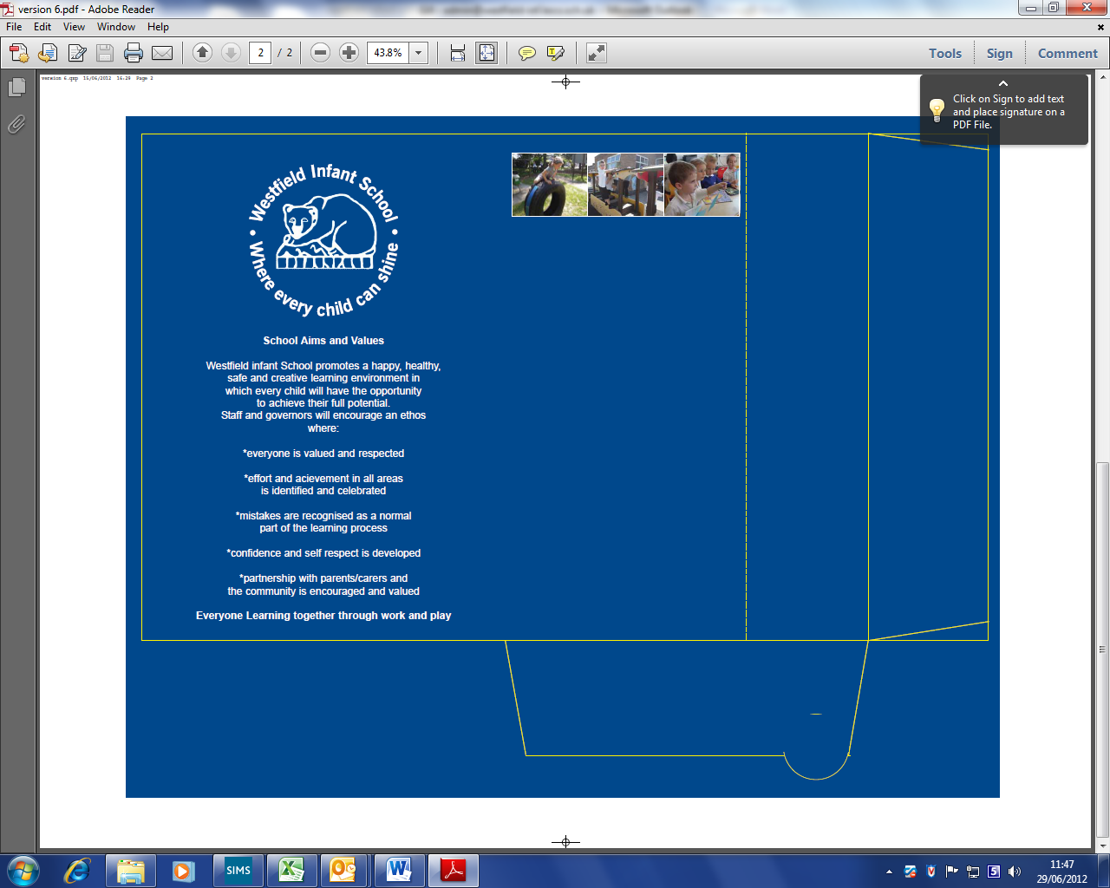

Agreed by Governors | Autumn 2024
Date for Review | Autumn 2025

SOCIAL MEDIA POLICY

Introduction

At Westfield Infant School, the Governors and staff fully recognise the contribution the school makes to safeguarding children. We recognise that the safety and protection of all pupils is of paramount importance and that all staff, including volunteers, have a full and active part to play in protecting pupils from harm.

We believe that the school should provide a caring, positive, safe and stimulating environment which promotes all pupils’ social, physical, emotional and moral development.
Westfield Infant School understands that social media is a growing part of life outside of school. We have a responsibility to safeguard our pupils against potential dangers when accessing the internet at school, and to educate our pupils about how to protect themselves online when outside of school.

We are committed to:

- Protecting our pupils from the dangers of social media
- Preventing and avoiding damage to the reputation of the school through irresponsible use of social media
- Protecting our staff from cyber bullying and potentially career damaging behaviour.

Ultimately, effective safeguarding of children can only be achieved by putting children at the centre of the system and by every individual and agency playing their full part, working together to meet the needs of our most vulnerable children, in line with Keeping Children Safe in Education 2024.

Training of Staff

At Westfield Infant School, we recognise that early intervention can protect pupils who may be at risk of cyber bullying or negative social media behaviour. All staff will receive training in identifying potentially at risk pupils.

Teachers and support staff will update themselves by reading and discussing the Social Media Policy annually as part of our school process and procedures.

Teachers and support staff will receive regular and ongoing training as part of their development.

Whilst recognising the benefits of this form of media for new opportunities for communication, this policy sets out the principles that Westfield Infant School staff, Governors and volunteers are expected to follow when using social media.

This policy applies to personal web space such as social networking sites (for example Facebook), blogs, microblogs such as Twitter, chatrooms, forums, podcasts, open access online encyclopaedias such as Wikipedia, social bookmarking sites and content sharing sites such as Flickr, Instagram. TikTok and YouTube. The internet is a fast moving technology and it is impossible to cover all circumstances or emerging media - the principles set out in this policy must be followed irrespective of the medium.
The policy is based around 4 key areas:

1. Use of social networking by staff and Governors in a personal capacity
2. Creation of network accounts by staff for use in education
3. Comments posted by parents/carers
4. Dealing with incidents of online bullying.

Use of social media sites by employees in a personal capacity

It is possible that a high proportion of staff will have their own social networking site accounts. It is important for them to protect their professional reputation by ensuring that they use their personal accounts in an appropriate manner.

Staff are advised as follows:

- That they familiarise themselves with social network sites’ privacy settings in order to ensure that information is not automatically shared with a wider audience than intended
- It is recommended that, as a minimum, all privacy settings are set to ‘friends only’, irrespective of use/purpose
- That they do not conduct or portray themselves, or allow friends to portray them, in a manner which may:
- bring the school into disrepute;
- post pictures or videos which could lead to valid parent/carer complaints;
- bring into question their appropriateness to work with children;
- contravene current National Teacher Standards. At the present time the Chair of Governors and the Headteacher strongly discourage any member of staff forming online friendships or entering into communication with parents/carers as this could lead to professional relationships being compromised.
- that they do not form online friendships or enter into online communication with pupils as this could lead to professional relationships being compromised, and/or safeguarding allegations being raised;
- post pictures or comment about school events;
- disclose sensitive, private or confidential information across private messaging.

Staff should:

- Consider others’ privacy and avoid discussing topics that may be inflammatory e.g. politics and religion, which could result in their professional reputation being compromised
- Consider what they ‘like, ‘share’ or ‘follow’ on social media sites e.g. politics and religion, which could result in their professional reputation being compromised
- Consider the pictures/videos they upload or post on a social media site and how this may portray them in their professional role working with children
- Be aware that if their use of social media/networking sites contravenes this policy, they will be subject to disciplinary action.

Inappropriate use by employees should be referred to the Headteacher in the first instance. If staff have concerns about the Headteacher’s use of social media they should be referred to the Chair of Governors.

Creation of social media accounts by school staff for use in education

All social media services must be approved by the Headteacher in advance of any educational work being undertaken.

Comments posted by parents/carers on social media sites

- Parents/Carers will be made aware of their responsibilities regarding their use of social media via this policy (in particular when their child joins the school), the school website, letter and school newsletters
- Parents/Carers are asked not to post images (photos and videos) of pupils other than their own children on social media sites unless they have the permission of parents/carers of other children pictured
- Parents/Carers are asked to raise queries, concerns or complaints directly with the school rather than posting them on social media
- Parents/Carers should not post malicious or fictitious comments on social media sites about any member of the school community
- Parents/Carers should not form online friendships or enter into online communication with employees, as this could lead to professional relationships being compromised.

If any posts regarding a member of our school community are posted on a social media site by members of the community who are not parents and carers, please inform the Headteacher at the earliest convenience.

Procedure the school will follow if inappropriate use continues

Westfield Infant School will always try to deal with concerns raised by parents/carers in a professional and appropriate manner and understands that parent/carers may not always realise when they have used social networking sites inappropriately. Therefore, as a first step, the school will usually discuss the matter with the parent/carer to try and resolve the matter and to ask that the relevant information be removed from the social networking site in question.

If the parent/carer refuses to do this and continues to use social networking sites in a manner the school considers inappropriate, the school will consider taking the following action:
- Take legal advice and/or legal action where the circumstances warrant this
- Set out the school’s concerns in writing, requesting that the material in question is removed and setting out any further action the school will take
- Contact the police where a crime may have been committed
- If the inappropriate comments have been made on a school website or online forum, the school may take action to block or restrict that individual’s access to that website or forum
- Contact the host/provider of the Social Networking site to complain about the content of the site and ask for removal of the information.

Should there be a post made by a person who is not a parent or carer, the headteacher will take the necessary action and report the post to the social media site. The Headteacher will take legal advice and/or legal action where the circumstances warrant this

Dealing with incidents of online (cyber) bullying

Our school Online safety and Anti Bullying Policies make sanctions regarding bullying using new technologies very clear. The DfE’s ‘Behaviour and Discipline in Schools’ policy indicates that the school can take action against incidents that happen outside school if it:

1. Could have repercussions for the orderly running of the school or
2. Poses a threat to another pupil or member of the public or
3. Could adversely affect the reputation of the school.

Use of social networking sites to harass, bully or intimidate would be covered by this irrespective of when/where the post was made.

Be SMART Online at Westfield Infant School

Through discrete computing lessons we encourage pupils to take a SMART approach to social media behaviour:

  - Safe – Do not give out personal information, or post photographs of yourself to people you talk to online. Follow age restriction rules
  - Meeting – Do not meet somebody you have only met online. We encourage parents/carers to speak regularly to their children about who they are talking to online
  - Accepting – We advise that pupils only accept emails and other forms of communication from people they already know
  - Reliable – We teach pupils about the dangers of believing everything they see online
  - Tell – We encourage pupils to tell a member of staff, parent/carer if they see anything online that makes them feel uncomfortable.

Photographs taken of Children

Westfield Infant School regularly takes photographs of children for use around the school, on the school website, Class Dojo and to send to the press. If parents/carers do not wish their child to be included in any of the above they should inform the Headteacher in writing. They will also have the option to make this known in the Parent/Carer Consent Booklet issued prior to their child starting school. Parents and carers are permitted to take photos and short videos of their children, for example; when they are in a performance, providing that any photos and videos containing images of other children are not put on any social media sites e.g. Facebook, Instagram, Snapchat. This is due to different family or background circumstances that could have a negative or potentially dangerous impact on individuals. Failure to follow this procedure could result in a personal or school wide ban on mobile phones and cameras in and around the school.

The website is regularly updated with photographs, where parental permission has been sought. Governors have been informed that any manipulation or distribution of images of children could result in prosecution. http://www.westfield-inf.leics.sch.uk/policies-1/

This policy will be reviewed annually.

Adopted by the Governing Board and Signed by Chair of Governors

Date:

