PSHE and Citizenship Policy

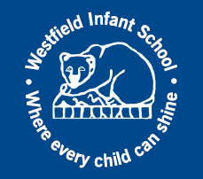

Agreed by Governors | Autumn 2024
Date for Review | Autumn 2025

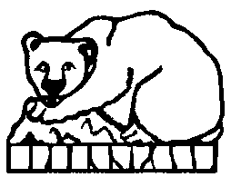

WESTFIELD INFANT SCHOOL

Introduction
This policy covers our approach to Personal, Social, Health and Economic education (PSHE) and Citizenship education. It aims to set out the purpose of PSHE and Citizenship education and the intended outcomes for pupils; it also includes our curriculum coverage and how it is delivered.
This policy takes into consideration the following legal requirements, national strategies and government guidance:
- Education Act
- Academies Act
- Department for Education Guidance for Personal, Social, Health and Economic (PSHE) Education 2020
- Department for Education Guidance for the teaching of the statutory Relationships Education, Relationships and Sex Education (RSE) and Health Education 2020

We believe PSHE and Citizenship education is integral to many aspects of school life and this policy therefore relates to these policies:
- Relationships and Sex Education
- Safeguarding and Child Protection
- Behaviour and Attendance
- Anti-Bullying

Rationale
PSHE and Citizenship education is currently a non-statutory subject. However, section 2.5 of the national curriculum asserts all state schools ‘should make provision for personal, social, health and economic education (PSHE)’. The PSHE Association states that, ‘PSHE education contributes to schools’ statutory duties outlined in the Education Act 2002 and the Academies Act 2010 to provide a balanced and broadly-based curriculum and is essential to Ofsted judgements in relation to personal development, behaviour, welfare and safeguarding.’ In addition, the Relationships and Health and Wellbeing areas of PSHE and Citizenship education have been compulsory in primary schools since September 2020.
We believe PSHE and Citizenship education is an important and necessary part of all pupils’ education. In our school, it is a key element of school life and, as well as explicit teaching sessions which will draw on good practice and national recommendations, it will be built into many aspects of the wider curriculum. Our school believes PSHE and Citizenship education is a shared responsibility of school staff, parents, carers, pupils and, where appropriate, the wider community.

Aims
PSHE and Citizenship education in our school aims to explore the knowledge and understanding children need to stay safe, be happy and healthy and fulfil their potential, while also preparing them for life, both in the present and future. It also aims to equip children with the skills they need to live successfully as citizens of the communities to which they belong and enables them to celebrate diversity and treat all people with kindness and respect. PSHE and Citizenship education in our school also aims to encourage children to develop positive mental health and emotional wellbeing, by empowering them with the knowledge of why this is important and how it can be achieved. We want to educate the whole child through our PSHE and Citizenship education and believe this positively impacts the individual, the school community, the wider community and the global community - both present and future.

- Our governing board will work closely with school staff to monitor the teaching and learning of PSHE and Citizenship education.

- Our headteacher and senior leaders will support all staff in school in the preparation and delivery of PSHE and Citizenship education and work to create a school ethos which supports and upholds content in the curriculum.

- Our PSHE and Citizenship education subject leader will create and implement a whole school scheme of work appropriate to our school setting. They will also support and monitor teaching and learning in this area.

- Our class teachers will deliver high quality weekly PSHE and Citizenship education lessons which follow the school’s scheme of work and current best practice.
- Our support staff will enhance the delivery of PSHE and Citizenship by providing targeted intervention wherever needed.

- Our pupils will engage respectfully and responsibly with all taught content.
- Our parents and carers will be fully informed about what their children will be learning and will be actively encouraged to participate in the curriculum where appropriate.

The Delivery of the PSHE and Citizenship Scheme of Work
In our school, PSHE and Citizenship education will be delivered in a way which is accessible to and inclusive of all pupils. These lessons will involve a variety of teaching methods and interactive activities to encourage pupil engagement. We aim to create a safe and supportive climate for learning in which all children can thrive, feel able to ask questions and discuss issues openly.
All of our pupils will participate in weekly PSHE and Citizenship education lessons and these will be taught by staff who are trained in delivering the specific content of the lessons. Ground rules will be established in class and pupils will be reminded regularly of these. Special consideration will be given when teaching particularly sensitive content; staff will be fully aware of the children in their class and how they might relate to the lesson content, providing extra support to enable participation. Distancing techniques will be employed in all PSHE and Citizenship education lessons, meaning that children are able to engage with and explore issues deeply without having to discuss their own lives and experiences.

The Content of the PSHE and Citizenship Education Scheme of Work
We use the Twinkl Life PSHE and Citizenship education scheme of work throughout Key Stage 1. This scheme of work and all of its resources have been produced to be fully in line with the Learning Outcomes and Core Themes outlined in the 2020 PSHE Association Programme of Study which is widely used by schools in England and is recommended and referred to by the DfE in all key documentation relating to PSHE provision in schools. The EYFS work to the standards in the PSED area of their curriculum.
All aims are taught through the three core areas of PSHE and Citizenship education, which are: Health and Wellbeing, Relationships and Living in the Wider World. All lessons will cover content in an age-appropriate manner.

Health and Wellbeing lessons will explore physical wellbeing, healthy lifestyles, mental health, growing and changing and keeping safe.
Relationships lessons will explore families and close positive relationships, friendships, managing hurtful behaviour and bullying, safe relationships and respecting self and others.
Living in the Wider World lessons will explore our shared responsibilities, communities, media literacy and digital resilience and economic wellbeing (money and aspirations, work and career) and British Values.

KS1
Years 1 and 2 will cover these objectives:
Healthy lifestyles (physical wellbeing)
H1. what keeping healthy means; different ways to keep healthy
H2. foods that support good health and the risks of eating too much sugar
H3. how physical activity helps us to stay healthy; ways to be physically active everyday
H4. why sleep is important and different ways to rest and relax
H5. simple hygiene routines that can stop germs from spreading
H6. that medicines (including vaccinations and immunisations and those that support allergic reactions)
can help people to stay healthy
H7. dental care and visiting the dentist; how to brush teeth correctly; food and drink that support dental
health
H8. how to keep safe in the sun and protect skin from sun damage
H9. different ways to learn and play; recognising the importance of knowing when to take a break from
time online or TV
H10. the people who help us to stay physically healthy

Mental health
H11. different feelings that humans can experience
H12. how to recognise and name different feelings
H13. how feelings can affect people’s bodies and how they behave
H14. how to recognise what others might be feeling
H15. to recognise that not everyone feels the same at the same time, or feels the same about the
same things
H16. ways of sharing feelings; a range of words to describe feelings
H17. things that help people feel good (e.g. playing outside, doing things they enjoy, spending time
with family, getting enough sleep)
H18. different things they can do to manage big feelings, to help calm themselves down and/or change
their mood when they don’t feel good

H19. to recognise when they need help with feelings; that it is important to ask for help with feelings and
how to ask for it
H20. change and loss (including death); to identify feelings associated with this; to recognise what helps
people to feel better
Ourselves, growing and changing
H21. to recognise what makes them special
H22. to recognise the ways in which we are all unique
H23. to identify what they are good at, what they like and dislike
H24. how to manage when they are finding things difficult
H25. to name the main parts of the body including genitalia (e.g. vulva, vagina, penis, testicles)
H26. growing and changing from young to old and how people’s needs change
H27. preparing to move to a new class/year group
Keeping safe
H28. rules and age restrictions that keep us safe
H29. to recognise risk in simple everyday situations and what action to take to minimise harm
H30. how to keep safe at home (including around electrical appliances) and fire safety (e.g. not playing
with matches and lighters)
H31. that household products (including medicines) can be harmful if not used correctly
H32. ways to keep safe in familiar and unfamiliar environments (e.g. beach, shopping centre, park,
swimming pool, on the street) and how to cross the road safely
H33. the people whose job it is to help keep us safe
H34. basic rules to keep safe online, including what is meant by personal information and what should
be kept private; the importance of telling a trusted adult if they come across something that scares
them
H35. what to do if there is an accident and someone is hurt
H36. how to get help in an emergency (how to dial 999 and what to say)
Drugs, alcohol and tobacco
H37. things that people can put into their body or on their skin; how these can affect how people feel

Relationships
Families and close positive relationships
R1. the roles different people (e.g. acquaintances, friends and relatives) play in our lives
R2. to identify the people who love and care for them and what they do to help them feel cared for
R3. different types of families, including those that may be different to their own
R4. to identify common features of family life
R5. that it is important to tell someone (such as their teacher) if something about their family makes them
unhappy or worried
Friendships
R6. how people make friends and what makes a good friendship
R7. how to recognise when they or someone else feels lonely and what to do
R8. simple strategies to resolve arguments between friends positively
R9. how to ask for help if a friendship is making them feel unhappy
Managing hurtful behaviour and bullying
R10. that bodies and feelings can be hurt by words and actions; that people can say hurtful things online
R11. how people may feel if they experience hurtful behaviour or bullying
R12. that hurtful (offline and online) behaviour - including teasing, name-calling, bullying and
deliberately excluding
others - is not acceptable; how to report bullying; the importance of telling a trusted adult
Safe relationships
R13. to recognise that some things are private and the importance of respecting privacy; that parts of
their body
covered by underwear are private
R14. understanding that sometimes people may behave differently online, including a person pretending
to be
someone they are not
R15. how to respond safely to adults they don’t know
R16. how to respond if physical contact makes them feel uncomfortable or unsafe
R17. knowing there are situations when they should ask for permission and also when their own
permission should be sought

R18. the importance of not keeping adults’ secrets (only happy surprises that others will find out
about eventually)
R19. understanding that they may feel pressure do something they don’t want to do, which may
make them unsafe; basic techniques for resisting this
R20. what to do if they feel unsafe or worried for themselves or others; who to ask for help and
vocabulary to use when asking for help; to keep trying until they are heard and the importance of this
Respecting self and others
R21. what is kind and unkind behaviour and how this can affect others
R22. how to treat themselves and others with respect; how to be polite and courteous
R23. to recognise the ways in which they are the same and different to others
R24. how to listen to other people and play and work cooperatively
R25. how to talk about and share their opinions on things that matter to them
Living in the Wider World
Shared responsibilities
L1. what rules are, why they are needed and why different rules are needed for different situations
L2. how people and other living things have different needs; the responsibilities of caring for them
L3. things they can do to help look after their environment
Communities
L4. the different groups they belong to
L5. the different roles and responsibilities people have in their community
L6. to recognise the ways they are the same as, and different to, other people
Media literacy & digital resilience
L7. how the internet and digital devices can be used safely to find things out and to communicate with
others
L8. the role of the internet in everyday life
L9. understanding that not all information seen online is true

Economic wellbeing: Money
L10. what money is; forms that money comes in; that money comes from different sources
L11. that people make different choices about how to save and spend money
L12. the difference between needs and wants; that sometimes people may not always be able to
have the things they want
L13. that money needs to be looked after; different ways of doing this
Economic wellbeing: Aspirations, work and career
L14. that everyone has different strengths
L15. that jobs help people to earn money to pay for things
L16. different jobs that people they know or people who work in the community do
L17. some of the strengths and interests someone might need to do different jobs

They will be taught through the following units:
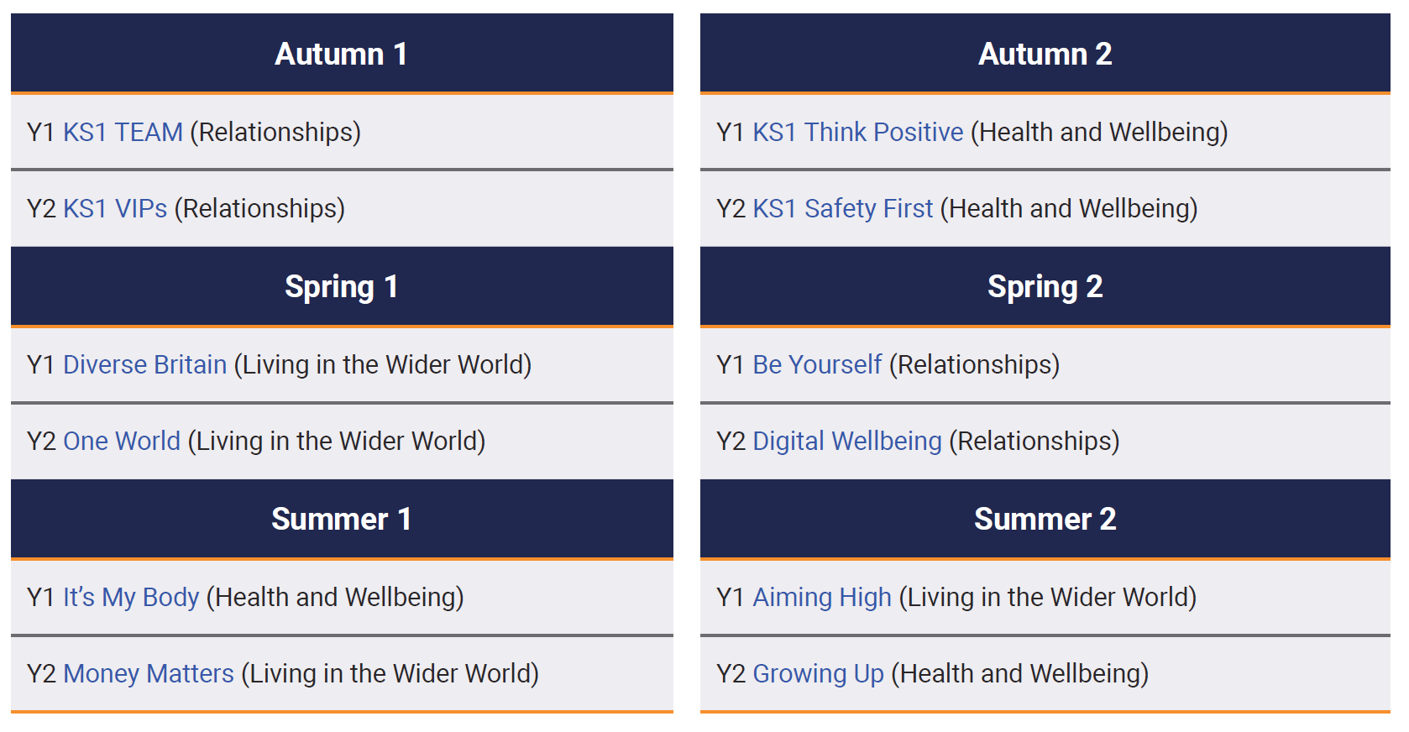

Through our liaison with Westfield Junior School, these units are built upon and progression continues into Key stage 2.

Assessment

Pupils’ learning will be assessed throughout each unit using the assessment materials accompanying the scheme of work. Pupils will also be involved in regular reflection of their own learning journey in relation to PSHE and Citizenship education. We believe this is pivotal to the embedding and progression of knowledge, skills, understanding and attitudes. This will help us to provide a curriculum which is relevant and meaningful to all pupils. However, due to the personal nature of taught content, we believe it is important that learning in PSHE and Citizenship education is seen as developmental and not as succeeding or failing. In our school, all children should feel they are succeeding in PSHE and Citizenship education, whatever their starting or ending point within a unit of work.
Confidentiality
For any child wishing to discuss something confidential relating to the lesson content, an opportunity will be provided in which the policies and protocols of safeguarding and confidentiality are adhered to.

Continuing Professional Development
The professional development needs of all staff in relation to the teaching and learning in PSHE and Citizenship education will be regularly assessed and monitored and relevant training and support provided. The subject leader for PSHE and Citizenship will regularly model and disseminate best practice, working closely with the SLT and named governor.

Working with Parents, Carers and the Wider Community
We greatly value our parents and carers; we believe that their understanding of PSHE and Citizenship and what their children will be learning is vital in gaining optimum outcomes.
At the beginning of each half term, parents and carers are informed of the teaching and learning for all subject areas, including PSHE. Should any questions or queries arise, parents and carers are welcome to discuss with their child’s class teacher. Parents and carers are invited to view this policy and our curriculum at any point.
We are committed to following government guidance on the rights and responsibilities of parents and carers concerning PSHE and Citizenship education.

Monitoring and Evaluation

Staff members responsible or monitoring teaching and learning in PSHE and Citizenship education are:

Mrs Sophie Bater (PSHE Leader)
Miss Katy Brown (PSHE Governor)
Mrs Jennifer Ruane (Headteacher)

Our arrangements for consulting with pupils:
To consult with pupils, we will involve them in regular self-reflection and discussion about their learning and enable them to raise additional learning they feel is needed; we will also consider what has been learned and how it can be implemented successfully in school.
Key action points learnt through our monitoring and evaluation will be fed into our action plans.

This policy will be reviewed annually.

This policy has been read, approved and signed by the Governing Board on……………………………………

Signed…………………………………………………………………Chair of the Governing Board

